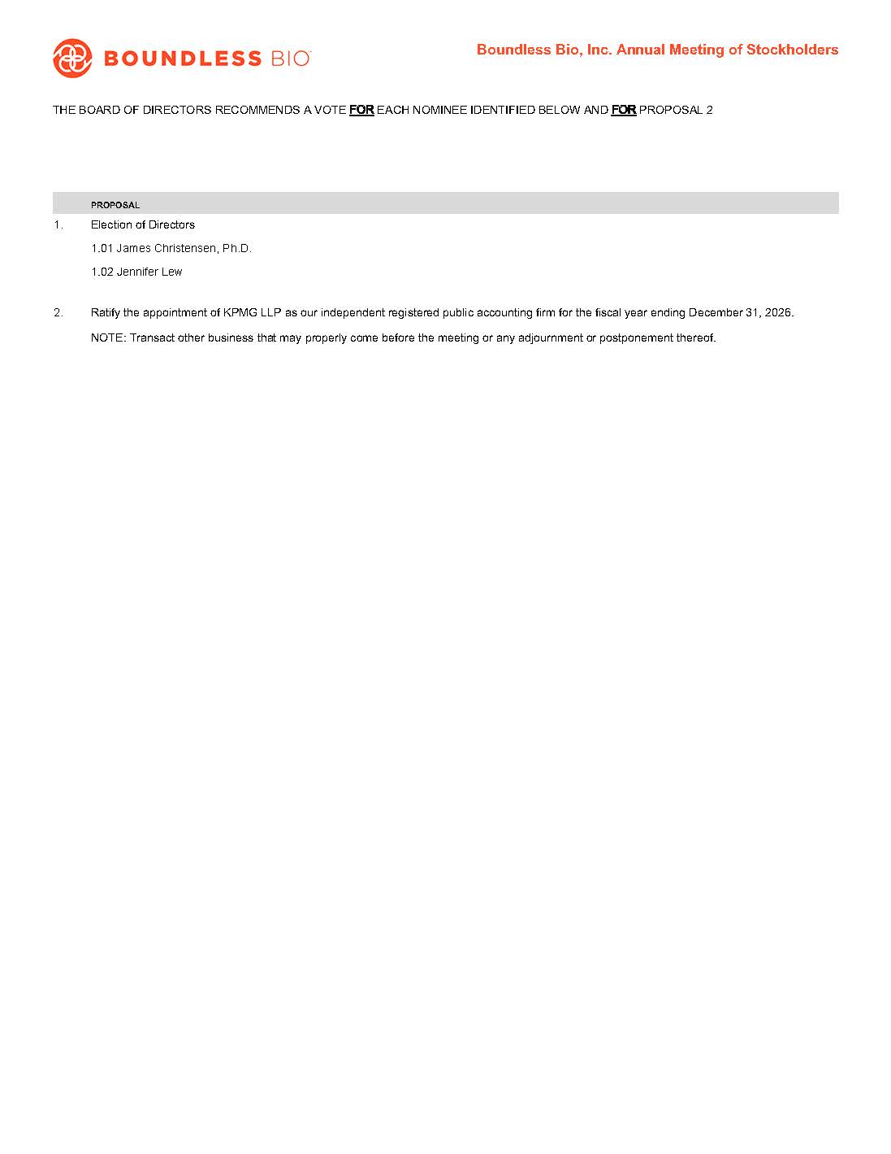
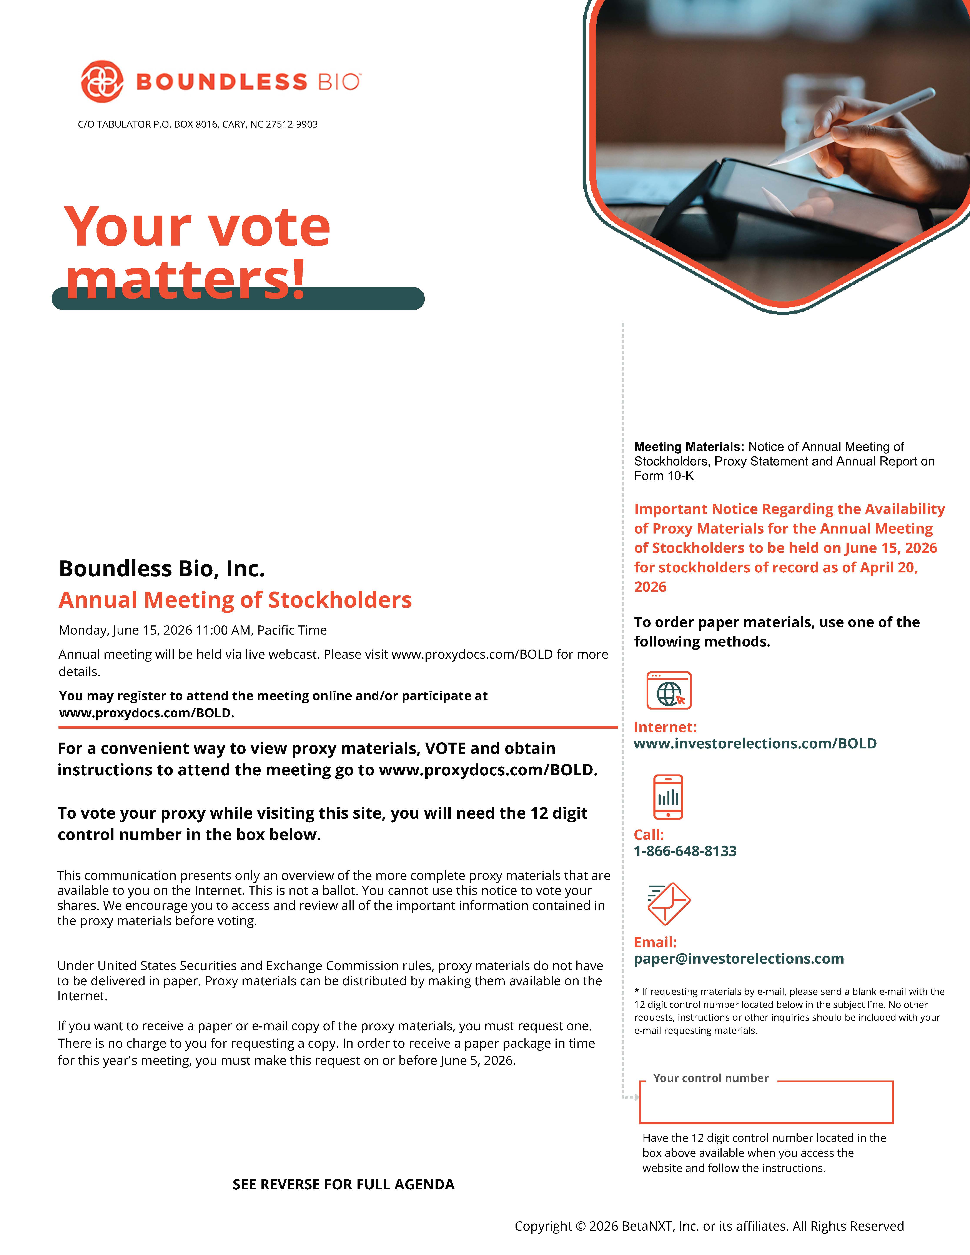
UNITED STATES
SECURITIES AND EXCHANGE COMMISSION
Washington, D.C. 20549

SCHEDULE 14A
Proxy Statement Pursuant to Section 14(a) of the
Securities Exchange Act of 1934
(Amendment No. )

Filed by the Registrant☒
Filed by a Party other than the Registrant☐
Check the appropriate box:

☐ | Preliminary Proxy Statement

☐ | Confidential, for Use of the Commission Only (as permitted by Rule 14a-6(e)(2))

☐ | Definitive Proxy Statement

☒ | Definitive Additional Materials

☐ | Soliciting Material under §240.14a-12
BOUNDLESS BIO, INC.
(Name of Registrant as Specified In Its Charter)
(Name of Person(s) Filing Proxy Statement, if other than the Registrant)
Payment of Filing Fee (Check all boxes that apply):

☒ | No fee required

☐ | Fee paid previously with preliminary materials

☐ | Fee computed on table in exhibit required by Item 25(b) per Exchange Act Rules 14a-6(i)(1) and 0-11

LOGO BOUNDLESS BIO C/O TABULATOLOGO BOUNDLESS BIO C/O TABULATOR P.O. BOX 8016, CARY, NC 27512-9903 Your vote matters! Boundless Bio, Inc. Annual Meeting of Stockholders Monday, June 15, 2026 11:00 AM, Pacific Time Annual meeting will be held via live webcast. Please visit www.proxydocs.com/BOLD for more details. You may register to attend the meeting online and/or participate at www.proxydocs.com/BOLD. For a convenient way to view proxy materials, VOTE and obtain instructions to attend the meeting go to www.proxydocs.com/BOLD. To vote your proxy while visiting this site, you will need the 12 digit control number in the box below. This communication presents only an overview of the more complete proxy materials that are available to you on the Internet. This is not a ballot. You cannot use this notice to vote your shares. We encourage you to access and review all of the important information contained in the proxy materials before voting. Under United States Securities and Exchange Commission rules, proxy materials do not have to be delivered in paper. Proxy materials can be distributed by making them available on the Internet. If you want to receive a paper or e-mail copy of the proxy materials, you must request one. There is no charge to you for requesting a copy. In order to receive a paper package in time for this year's meeting, you must make this request on or before June 5, 2026. Meeting Materials: Notice of Annual Meeting of Stockholders, Proxy Statement and Annual Report on Form 10-K Important Notice Regarding the Availability of Proxy Materials for the Annual Meeting of Stockholders to be held on June 15, 2026 for stockholders of record as of April 20, 2026 To order paper materials, use one of the following methods. Internet: www.investorelections.com/BOLD Call: 1-866-648-8133 Email: paper@investorelections.com * If requesting materials by e-mail, please send a blank e-mail with the 12 digit control number located below in the subject line. No other requests, instructions or other inquiries should be included with your e-mail requesting materials. Your control number Have the 12 digit control number located in the box above available when you access the website and follow the instructions. SEE REVERSE FOR FULL AGENDA Copyright © 2026 BetaNXT, Inc. or its affiliates. All Rights Reserved

LOGO BOUNDLESS BIO Boundless Bio, Inc. Annual Meeting of Stockholders THE BOARD OF DIRECTORS RECOMMENDS A VOTE FOR EACH NOMINEE IDENTIFIED BELOW AND FOR PROPOSAL 2 PROPOSAL 1.Election of Directors 1.01 James Christensen, Ph.D. 1.02 Jennifer Lew 2. Ratify the appointment of KPMG LLP as our independent registered public accounting firm for the fiscal year ending December 31, 2026. NOTE: Transact other business that may properly come before the meeting or any adjournment or postponement thereof.

